Software Project Management

### Lab 4

March 15, 2024

Emily Lai 100825007

Alina Mathew 100853412

Natasha Naorem 100845321

### Introduction

### Activity Diagram

The following tasks were estimated in the activity diagram:

| Task | Estimated time | Depends on tasks |
| --- | --- | --- |
| Hire/recruit staff | 1 month | N/A |
| Design hardware for admin module | 3 months | Hire/recruit staff |
| Design software MVP | 2 months | Hire/recruit staff |
| Develop databases and APIs | 3 months | Design hardware for admin module  Design software MVP |
| Develop user application | 5 months | Develop Databases and APIs |

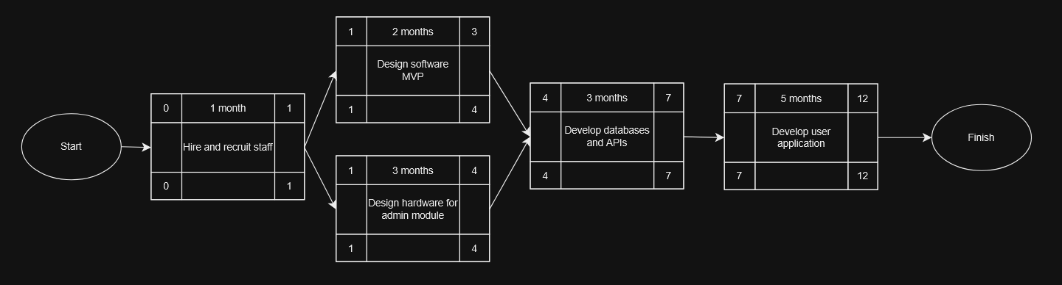

### Risks

One risk related to the tasks in the activity diagram is related to the task of designing hardware for the admin module. In this case, there is a risk of issues with compatibility with existing infrastructure. It is possible that the hardware created for the admin module may have difficulties with integrating to the existing infrastructure or railway systems. Any delays in developing this will lead to delays in the future steps in the timeline.

The countermeasure for this risk will be compatibility testing and hardware system validation. The project must be tested against the existing infrastructure and systems, and relevant experts of the railway, as well as stakeholders, will be collaboratively worked with, so that the hardware aligns with the requirements and constraints specified by the experts.

Another relevant risk is related to developing the databases and APIs. As the railway tracking system can be applied to railway systems of various sizes, it is possible to have the risk of poor scalability and performance over time. When user traffic increases and data loads subsequently increase, the system may not be able to keep up.

This risk can be counter-measured by regularly testing the system for performance, as well as designing the database with scalability in mind so that it will be able to support growth in the future. Many techniques can be applied, such as horizontal scaling and load balancing, in order to make the system more scalable.

### Team Members

Team Member 1: Amy, the Hiring Manager

Amy, the hiring manager, will be in charge of hiring and recruiting staff for this project. She will be responsible for either recruiting staff from other areas of the company, or hiring new staff members to take on this project.

Team Member 2: Ben, the Hardware Engineer

Ben, the hardware engineer, will be in charge of designing and implementing the hardware components that are necessary to build the admin module for the railway tracking system.

Team Member 3: Cat, the Software Engineer

Cat, the software developer, will be responsible for the development of the railway tracking system software. This software team will have multiple responsibilities, including designing the software MVP and developing the user application.

Team Member 4: Dave, the Data Engineer

Dave, the data engineer, will be responsible for developing the databases for the railway tracking system. Dave will need to ensure the database is functional and scalable.

### Microsoft Project Professional Diagram

